VACCINECARE
VACCINATION MANAGEMENT SYSTEM
Updated Project Documentation

Faculty | Sir Murtaza Saeed
Batch | 2512D
Group | Vaccination Management System
Project | VaccineCare
Team Members | - Muskan • Javeria • Umaima Huzaifa
Interface documentation updated to match the current VaccineCare screenshots.

1. Home Page
The VaccineCare Home Page is the main landing page of the Vaccination Management System. It introduces the portal as a clinical system for organizing vaccination records, dose schedules, and vaccine stock information. The interface uses a dark navy visual theme with cyan and blue highlights to create a modern healthcare-focused appearance.
- Navigation bar with VaccineCare branding and links for Features, Services, and About System.
- Quick access buttons for Log in and Register.
- Hero message focused on building strong immunity and protecting children from harmful pathogens and germs.
- A prominent Get Started action and a Sign In action for user access.
- Visual disease/immunity artwork and an Active Disease Shield information card.
Current Home Page Interface
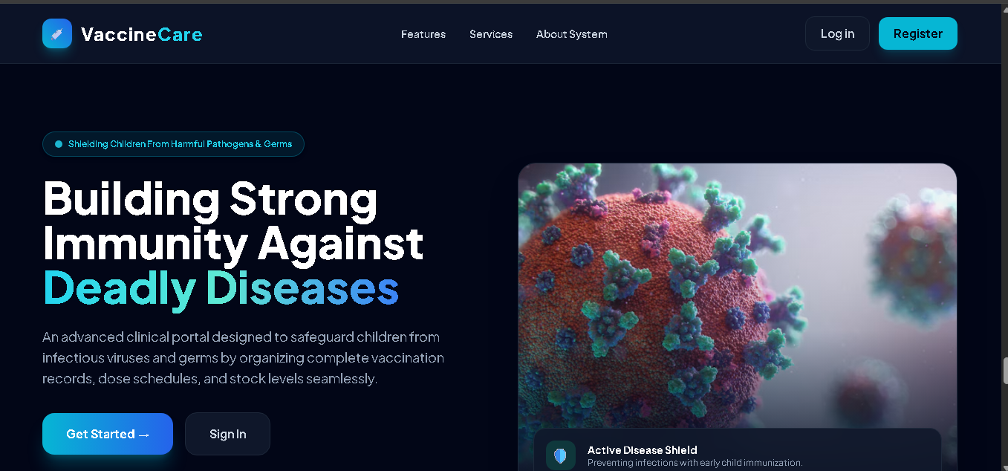

2. System Features
The System Features section presents the core capabilities available in the VaccineCare portal. The updated interface contains three main feature cards that describe how the system supports patient management, vaccine inventory, and vaccination records.
Patient Records  Register children with guardian details and view instant history. | Vaccine Inventory  Monitor vaccine stocks, doses, and storage guidelines easily. | Vaccination Logs  Assign vaccines, log dates, and track status with instant CRUD actions.

Current System Features Interface
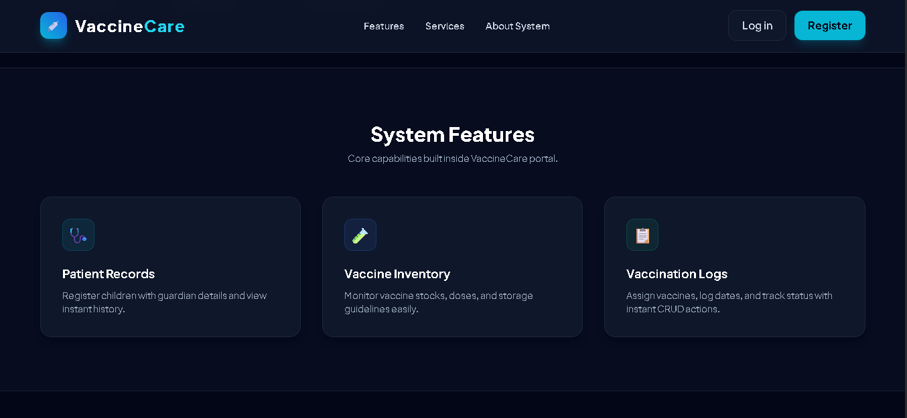

3. About System Page
The About System page provides the technical and functional overview of VaccineCare. According to the current interface, the portal is engineered for modern pediatric clinical operations and focuses on reducing manual paperwork while maintaining digital vaccination records.
Core Objective  To eliminate manual paperwork in pediatric clinics by maintaining digital records of newborn children and their mandatory immunization logs. | Technology Stack  Laravel 11, Tailwind CSS, MySQL DB, and Breeze Auth. | System Benefits  Real-time record lookup; vaccine stock inventory monitoring; secure authentication and CRUD logs.

Current About System Interface
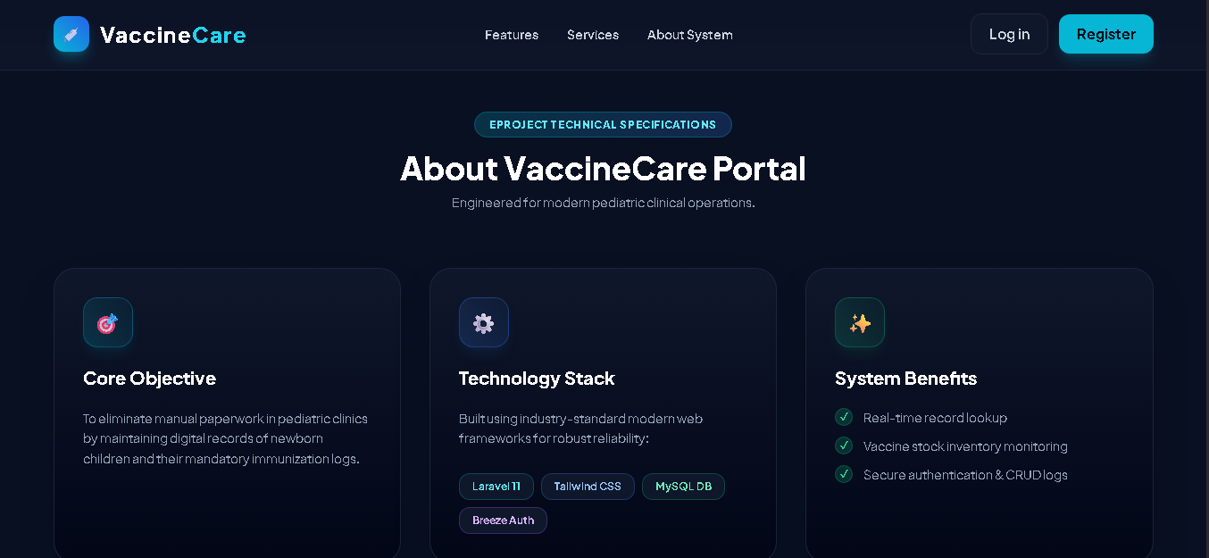

4. Authentication Pages
VaccineCare includes dedicated authentication screens for secure access to the portal. The screenshots show a Log In page for existing users and a Register page for creating a new account.
4.1 Log In
- Email Address field
- Password field
- Remember me option
- Forgot password link
- Log In button
- Link to Register here for users without an account
4.2 Register
- Full Name field
- Email Address field
- Password field
- Confirm Password field
- Register Account button
- Link to Log in here for existing users
Log In Screen | Register Screen
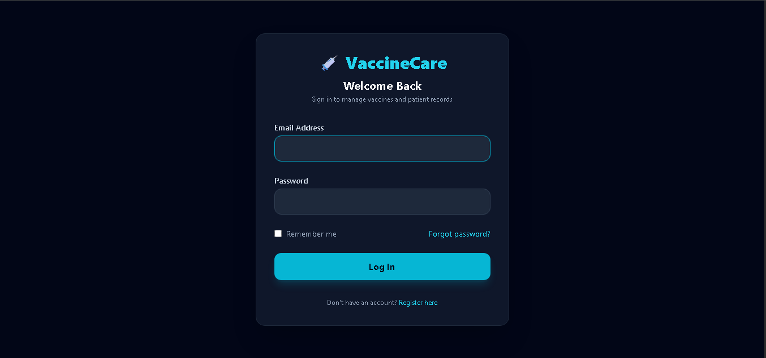 | 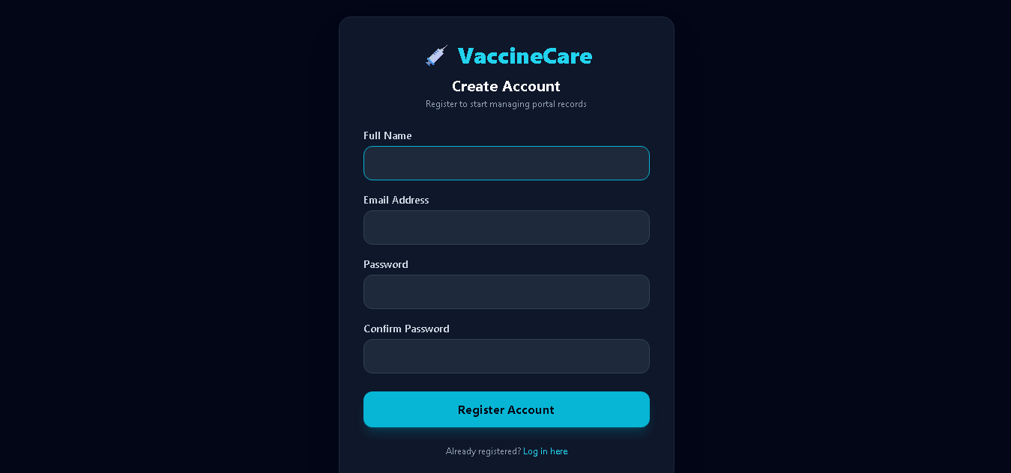

Thank you for reading the updated VaccineCare project documentation.

